**Corda Development – Java**

1. State creation
2. Flow creation
3. Smart contract creation
4. Command
5. Using Attachments

**Understanding Corda Hello World APP**

1. **State creation**

Any state can be created. These states are consumed by the transactions. There can be inputs/outputs ( UTXO)

**Interface to be implemented ( This is a Kotlin interface)**

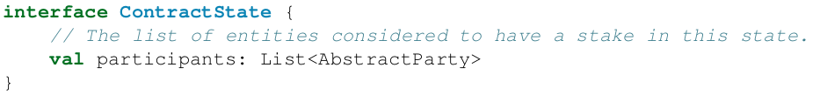

**Example – Importing a state**

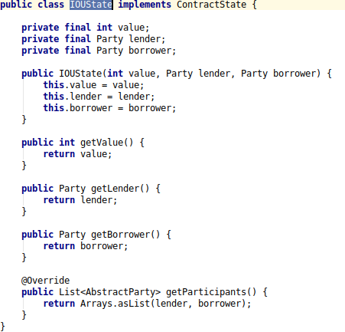

* **Party – Built in Corda type** which denotes the participants who can work with this particular state

1. **Flow creation**

* Corda has got many pre-built flows which can be used by developers instead of implementing a new one.
* In case of specific requirement, flows can be built on our own

**Java Implementation**

* FlowLogic class must be extended
* Call() method – Write flow logic/conditions

**Different types of Flows**

**Token Issuance Flow**